Joint Submission to the Universal Periodic Review of

PHILIPPINES

27th Session of the UPR Working Group of the Human Rights Council
May 2017

Report on Philippines’ Compliance with its Human Rights Obligations
in the Area of Women's Reproductive and Sexual Health

September 22, 2016

Submitted by:

Catholics for Reproductive Health (C4RH)
Center for Reproductive Rights
EnGendeRights Inc.
Filipino Freethinkers
Population Services Pilipinas Inc. (PSPI)
WomanHealth Philippines Inc.
Women’s Global Network for Reproductive Rights (WGNRR)

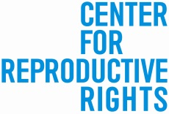
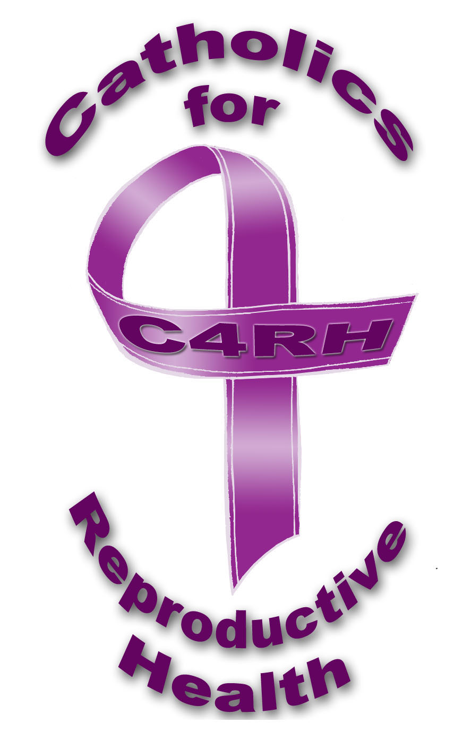
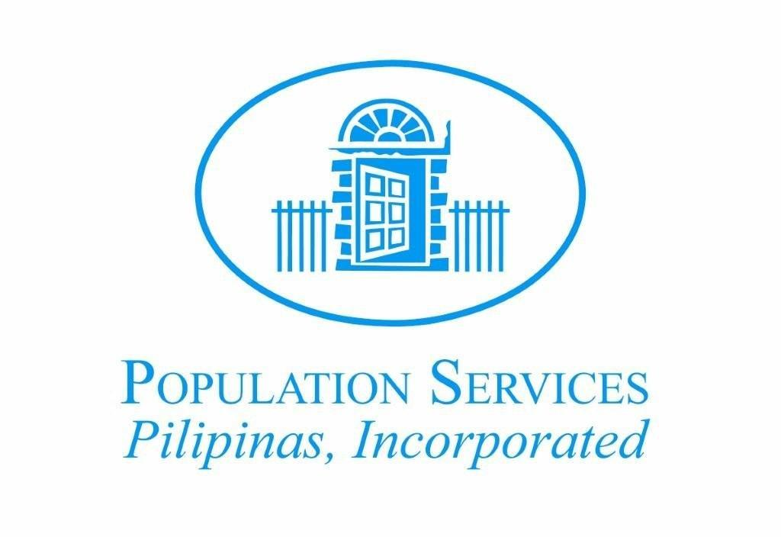

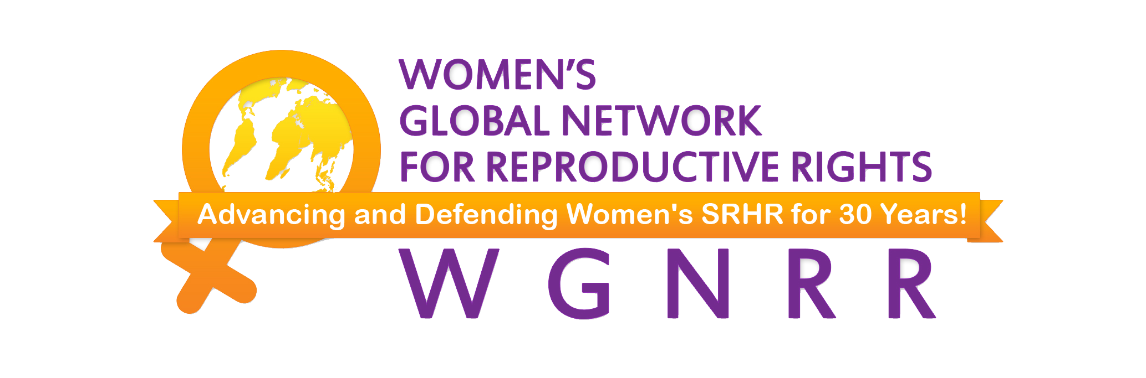

1. In accordance with Human Rights Council (HRC) Resolution 5/1, we present this submission as non-governmental organizations (NGOs) to supplement the report of the Government of the Philippines (the Government), scheduled for review by the HRC during its 27th session.

2. This submission follows up on specific recommendations accepted by the Government during its 2012 Universal Periodic Review (UPR), concerning the effective implementation of the Magna Carta of Women (MCW), promotion of the right to sexual and reproductive health and rights, and improvement of maternal health. While certain steps have been taken by the Government to implement these recommendations such as the adoption of a national reproductive health law and a national inquiry on reproductive health and rights, this submission presents information about recent developments and ongoing human rights violations experienced by women and girls in the Philippines as a result of persistent legal, policy, and practical barriers to the full range of contraceptive information and services, safe and legal abortion, and quality post-abortion care services which have undermined the implementation of the UPR recommendations.

OVERVIEW OF THE NATIONAL REPRODUCTIVE HEALTH SITUATION

3. Government data released in 2013 estimates that there are still 5.7 million women who have an unmet need for modern contraceptives and three in every ten pregnancies are unplanned or mistimed. Estimates of the number of abortions has increased from 560,000 in 2008 to 610,000 in 2012 with most being performed clandestinely and in unsafe conditions due to the criminal ban on abortion. Evidence published in 2013 also reflects that there are a significant number of women who experience abortion complications and are in need of urgent medical care—an estimated 100,000 women sought post-abortion care in 2012; approximately two in three women who terminate a pregnancy experience a serious and often life-threatening complication. Negative attitudes of health care providers and high costs prevent an estimated one in three women with complications from receiving humane and timely post-abortion care. Further, the maternal mortality ratio (MMR) has remained persistently high compared to the average for the Southeast Asia sub-region; in fact, government data released in 2014 shows an increase from 162 to 221 deaths per 100,000 live births between 2006 and 2011. An estimated 1,000 maternal deaths in 2008—roughly three deaths a day—are caused by unsafe abortions. Furthermore, a 2015 report reflects that the number of teenage pregnancies in Asia-Pacific has decreased with the exception of the Philippines where one in ten young women (aged between 15 and 19) is already a mother or pregnant.

INTERNATIONAL LEGAL FRAMEWORK

4. Since 2012, United Nations treaty monitoring bodies (UN TMBs) have repeatedly expressed concern about a broad range of human rights violations arising from the Government’s failure to ensure women’s and girls’ reproductive rights. In response to a request brought by the Center and partner NGOs under article 8 of the Optional Protocol to the Convention on the Elimination of All Forms of Discrimination Against Women (CEDAW), the Committee on the Elimination of Discrimination Against Women (CEDAW Committee) conducted a special inquiry in the Philippines in 2012 and found the Government liable of “grave and systematic” reproductive rights violations because of discriminatory legal and policy restrictions resulting in the denial of access to the full range of reproductive health services including contraceptives and safe abortion services. In 2016, the CEDAW Committee reiterated its concern about the lack of implementation of its recommendations in its inquiry report. Similar concerns were expressed by the Human Rights Committee in 2012 and the Committee against Torture in 2016.

5. As a signatory to core international human rights treaties, the Government must repeal or amend discriminatory laws and policies including those criminalizing abortion and requiring parental or spousal authorizations to access reproductive health services and information, and to adopt appropriate legislative and budgetary measures to ensure fulfilment of women’s and girls’ reproductive rights. Specifically, the Government is obligated to improve maternal health and lower the MMR; provide access to the full range of contraceptive information and services to prevent unintended pregnancies; ensure access to safe and legal abortion services; provide access to humane, non-judgmental and timely post-abortion care to prevent forced pregnancies, unsafe abortions, and life-threatening complications. Further, the Government must ensure that women and girls are provided with recourse to timely, accessible, effective and transparent remedies in cases of reproductive rights violations including restitution, compensation, rehabilitation, satisfaction and guarantees of non-repetition.

6. As one of the member states of the United Nations which adopted the Millennium Development Goals, the Government failed to meet targets under Goal 5 to improve maternal health. In its progress report published in 2014, the country’s high MMR, as mentioned above, and contraceptive prevalence rate (CPR) of 48.9% was not on track to meet the goals i.e. MMR of 52 per 100,000 live births and CPR of 63%. Further, the Government committed to the Sustainable Development Goals in 2015 and is obliged under Goals 3 (ensure healthy lives and promote well-being for all at all ages) and 5 (achieve gender equality and empower all women and girls) to reduce its MMR to less than 70 per 100,000 live births and to ensure the universal access to sexual and reproductive health care services and reproductive rights.

NATIONAL LEGAL FRAMEWORK

7. The Philippine Constitution and national laws guarantee women’s right to health including reproductive health and access to justice in cases of violations. Since the last UPR, the Government took the commendable step of enacting the Responsible Parenthood and Reproductive Health Act (RPRHA) in December 2012 which strengthened and reaffirmed the guarantees provided in the MCW concerning women’s and girls’ right to reproductive health services, including access to the full range of contraceptives and post-abortion care. Further, the RPRHA and MCW each provide for the creation of mechanisms for women and girls to seek and obtain redress in cases of reproductive rights violations. The RPRHA provides for the designation of Reproductive Health Officers (RHOs) to receive complaints in all public health care facilities and facilitate women’s and girls’ access to reproductive health information and services; the MCW designates the Commission on Human Rights (CHR) as the Gender and Development Ombud which shall establish guidelines that will facilitate women’s and girls’ access to justice.

8. Notwithstanding the enactment of laws promoting reproductive rights, abortion remains illegal in the Philippines with no clear exceptions, even when a woman’s life or health is in danger, when pregnancy is a result of rape or incest, or in cases of fetal impairment. The ban continues to exist notwithstanding the enactment of the MCW which requires the Government to review and, when necessary, amend and/or repeal existing laws that are discriminatory to women. Furthermore, the RPRHA reaffirms that abortion is illegal and punishable by law and explicitly excluded abortion from the definition of “reproductive health rights.” Consequently, although the RPRHA is a landmark piece of legislation and its implementation has been prioritized in the new administration’s ten-point socioeconomic agenda, it only provides a partial response to women’s reproductive health needs and concerns in the Philippines.

LEGAL, POLICY AND BUDGETARY BARRIERS TO THE FULL RANGE OF CONTRACEPTIVE INFORMATION AND SERVICES

9. Legal and policy restrictions on modern contraceptives including emergency contraception. After the inquiry, the CEDAW Committee called for the revocation of two executive orders (EOs) in Manila—Executive Order 003 (EO 003) and Executive Order 030 (EO 030) which effectively banned modern contraceptives in all public health care facilities and public funding for the same. Despite legislative guarantees of contraceptive information and services under the MCW and RPRHA and recommendations by several UN TMBs to revoke the EOs, the Government has not taken any step to explicitly repeal them leaving women to continue to face barriers when accessing care due to varying interpretations of the enforcement of said EOs. Further, in the absence of official action against the Manila EOs, other local government units (LGUs) have adopted similarly restrictive laws and policies on contraceptives. For example, in 2015, the mayor of Sorsogon City issued Executive Order 3 (EO 3) to declare the city “pro-life” and effectively banned modern contraceptives in all public health care facilities. While civil society groups have been calling for government action, the EO remains in place.

10. Women and girls in the Philippines have no access to the levonorgestrel-only pill, an internationally recognized form of emergency contraception which the WHO has recognized as an essential drug. While the drug Postinor—a levonorgestrel-only pill—was previously approved in 1999 by the Government for victims of sexual violence, it was de-listed from the Philippine registry of drugs by the Food and Drug Administration (FDA) in 2001. Access to emergency contraception is particularly important for survivors of sexual violence; government data in 2013 shows that over 10,000 women aged 15-49 have experienced sexual violence, with a higher incidence among women who have five or more children in comparison to women with less or no children.

11. Judicial orders undermining contraceptive access. Constitutional challenges to the RPRHA and the decisions of the Supreme Court have led to violations of women’s and girls’ reproductive rights. In 2013, several key provisions of the RPRHA were declared unconstitutional by the Supreme Court. As a result, health care providers are permitted to refuse to carry out “elective” reproductive health procedures such as ligation or vasectomy for married individuals on the ground of lack of spousal consent, and access to modern contraceptives for minors including those who are already parents or have suffered miscarriage for lack of parental consent. The decision disregards human rights standards specifically recognizing the state obligation to ensure that spousal and parental consent are not required to access reproductive health services and that there is a duty to refer in cases of conscientious objection. In 2015, the Supreme Court further impeded women’s and girls' access to contraceptives by issuing a temporary restraining order (TRO) which is effective indefinitely and prohibits the Department of Health (DoH) and any of its agents from distributing and promoting certain forms of hormonal contraceptives and from approving applications for certification of contraceptive drugs and devices. This 2015 order has been cited as a basis for recent significant budget cuts on contraceptive supplies in 2016 which are discussed below. In its September 2016 decision, the Supreme Court denied the lifting of the TRO and issued narrow directives that must be complied with by the DoH and FDA before certification, re-certification, distribution and administration of any contraceptive drugs and devices can be made.

12. Lack of funding for modern contraceptives. Following the special inquiry, the CEDAW Committee recommended that the Government address the unmet need for contraception by effectively implementing the MCW and RPRHA and providing adequate funding for contraceptive supplies. Contrary to its obligations, the Government has failed to ensure the availability of adequate funding for the implementation of the RPRHA. In fact, budget cuts have been made each year since the RPRHA came into effect, including the recent cuts in 2016 which have resulted in a reduction of Php 1 billion (approximately USD 21 million) specifically allocated for modern contraceptives. These cuts dramatically and disproportionately impact poor women who are dependent on the public health system for these services—over 11 million women of reproductive age are dependent on the Government's provision of free contraceptives and currently face an increased risk of unplanned pregnancies.

13. Absence of effective remedies. Following the inquiry, the CEDAW Committee urged the Government to allow the CHR to receive complaints and to provide remedies in cases of reproductive rights violations and found that undue delay in the Osil v City of Manila, a petition filed by residents of Manila in 2008 to challenge EO 003 as unconstitutional, “undermin[ed] the effectiveness of available remedies.” Since 2012, adverse judicial decisions, weak mechanisms, and government inaction have created a culture of impunity for reproductive rights violations. In 2014, the Osil case was dismissed on the grounds that the issue to be decided was a "moot point", following the enactment of the RPRHA. Furthermore, while the RPRHA provides for the designation of RHOs, there is still no publicly available information to what extent they have been established in all of the LGUs and are handling complaints.

14. In 2015, the CHR, acting as the Gender and Development Ombud, issued the Gender Ombud Guidelines. As a national human rights institution and the Gender Ombud, the CHR conducted its first national inquiry on reproductive health and rights between March and May 2016. As of September 2016, an official report of the CHR on the inquiry is yet to be released although, in its 2016 report to the CEDAW Committee, the CHR noted that its findings of violations are “merely recommendatory” which, based on experience, are not favorably acted upon by Government agencies. The CEDAW Committee recommended that the Government ensure the legal and binding effect of CHR’s resolutions.

LACK OF ACCESS TO SAFE AND LEGAL ABORTION AND QUALITY POST-ABORTION CARE SERVICES

15. Proposed increased penalties for abortion. As noted above, the Philippines has one of the most restrictive laws on abortion globally forcing women and girls to resort to unsafe abortions and leading them to suffer life-threatening complications. Since the last UPR, UN TMBs have repeatedly urged the Government to review the country’s criminal abortion ban and legalize abortion in certain circumstances. Following its inquiry in 2015, the CEDAW Committee recommended that the Government decriminalize abortion on all grounds and legalize it to save or protect the life and health of the woman or girl, in cases of pregnancies resulting from rape or incest or when there is serious fetal impairment. In 2012, the Human Rights Committee made similar recommendations to review the abortion ban recognizing the link between unsafe abortions and maternal deaths. In 2016, both the Committee Against Torture and CEDAW Committee recommended the legalization of abortion on certain grounds.

16. Without regard to the serious harm to women’s and girls’ health and lives caused by the ban, since 2012, the Government has repeatedly tried to impose heavier penalties on abortion, including most recently the proposed regressive language under the country’s penal code. A draft code submitted to Congress by the Department of Justice in August 2014 maintains the total ban on abortion and increases the penalties imposable on those involved in the performance of abortions, such that a woman who obtains or herself performs an abortion may be imprisoned for up to six years with an additional fine of up to an equivalent of twenty times her average daily income.

17. Barriers to seeking PAC. As discussed above, the MCW and RPRHA both guarantee the right to post-abortion care. These laws, together with the DoH policy on “Prevention and Management of Abortion and Its Complications” (PMAC) issued in 2000, promote women’s and girls’ right to humane, non-judgmental and compassionate treatment for post-abortion complications. Despite these guarantees, the criminalization of abortion and surrounding stigma, high costs of post-abortion care, and biased attitudes of health care providers prevent women and girls from seeking timely and quality medical treatment. Testimonies gathered by the Center and EnGendeRights in 2014 indicate that women and girls who seek post-abortion care have suffered ill-treatment, including being verbally abused, threatened with prosecution, made to wait for more than 24 hours before receiving care, detained in jail while under recovery, and out rightly denied treatment. These are contrary to World Health Organization guidelines and a wide range of human rights guaranteed under several major treaties particularly the recommendations issued by the CEDAW Committee, as a result of the inquiry, which called on the Government to provide women with access to quality post-abortion care in all public health care facilities and ensure that women experiencing post-abortion complications are not reported to law enforcement authorities, threatened with arrest, or subject to verbal and physical abuse. In 2015, after being formally notified of the rampant violations and provided with evidence of the same, the Philippine Commission on Women raised the issue with the DOH which is now developing a new policy on post-abortion care. As of September 2016, the DOH has yet to adopt the new policy.

18. Impunity for ill-treatment of women seeking post-abortion care. The Government has yet to fulfil its obligation to establish and implement effective accountability mechanisms to remove all barriers women and girls face in accessing justice and to ensure that they can file complaints without fear of retaliation. Since the last UPR, existing complaint mechanisms have not been strengthened, including those under the Gender Ombud Guidelines, to provide protection against retaliation or immunity for women and girls making them vulnerable to reprisals and criminal prosecution for illegal abortion. The need for protection is particularly critical to promote accountability for the ill-treatment because arrests of women seeking abortions and those assisting them continue making women’s and girls’ fear of abuse and prosecution well-founded. As confirmed by the CHR, the continuing ban on abortion also promotes the stigma on abortion and legitimizes the abuse and discrimination women and girls face when seeking access to post-abortion care.

QUESTIONS

We respectfully urge the Member States to express concern about the violations of women’s and girl’s rights and threats to their survival and well-being arising from the lack of access to contraceptive information and services, abortion, post-abortion care and effective accountability mechanisms and to encourage the Government to do more to prevent and address the resulting human rights violations by raising the following questions:

- What steps are being taken by the Government to ensure the full implementation of laws guaranteeing women’s and girls’ access to the full range of reproductive health information and services including modern contraceptives and post-abortion care, for example by lifting the 2015 Supreme Court order prohibiting certain hormonal contraceptives; mandating referrals for all hospitals in cases of conscientious objection; removing the need for parental and spousal consent for certain reproductive health goods and services; and allocating adequate budgetary measures?

- What measures are being adopted by the Government to ensure that restrictive laws and policies in contravention of the MCW and RPRHA, including orders from local government units effectively banning modern contraceptives, are immediately revoked and recognized as legally invalid?

- What steps are being taken by the Government to decriminalize abortion on all grounds and legalize abortion in cases of rape, incest, threats to the life or physical or mental health of the pregnant woman, or fetal impairment, in line with human rights standards and as urged by different UN TMBs?

- What measures are being adopted by the Government to ensure that women and girls who file complaints for reproductive rights violations, e.g. abuse when seeking post-abortion care and denial of access to modern contraceptives, are protected from retaliation and provided with effective remedies including compensation?

RECOMMENDATIONS

Following up on past UPR recommendations to the Government on the promotion of sexual and reproductive health and improvement of maternal health, we request the Member States to consider making the following recommendations:

- To ensure and facilitate women’s and girls’ access to the full range of contraceptive information and services including modern contraceptives and emergency contraceptives, by fully implementing the RPRHA and adequately investing in reproductive health programs, in addition to immediately reviewing and revoking all discriminatory laws and policies that contravene the MCW and RPRHA and the Government’s human rights obligations.

- To ensure and facilitate women’s and girls’ access to humane, nonjudgmental and quality post-abortion care as guaranteed under the RPRHA, MCW and PMAC policy.

- To take immediate steps to review the criminal abortion ban, decriminalize abortion on all grounds and legalize it in cases where a pregnant woman’s or girl’s life or physical or mental health is in danger, where the pregnancy is a result of rape or incest, and in cases of fetal impairment.

- To provide redress for human rights violations concerning women’s and girls’ reproductive health by establishing and enforcing effective accountability mechanisms that provide timely and appropriate remedies and to remove all barriers that impede their access to justice.

The Magna Carta of Women, Rep. Act No. 9710, sec. 17(3) (August 14, 2009) (Phil.) [hereinafter MCW].
Human Rights Council, Report of the Working Groups on the Universal Periodic Review: Philippines, para. 129.7, 129.40, 129.41, 131.34, 131.35, U.N. Doc. A/HRC/21/12 (2012).
Department of Health (DOH), The First Annual Consolidated Report on the Implementation of the Responsible Parenthood and Reproductive Health Act of 2012 (R.A. No. 10345) at 20 (2014) (Phil.).
Philippines Statistical Authority et al., Philippines National Demographic and Health Survey 2013, at 64 (August 2014) [hereinafter NDHS 2013].
The Guttmacher Institute, Unintended Pregnancy and Unsafe Abortion in the Philippines: Causes and Consequences (July 2013), available at http://www.guttmacher.org/pubs/FB-UPUAP.html [hereinafter Guttmacher Institute, Unintended Pregnancy (2013)].
Id.
Id.
Guttmacher Institute, Unintended Pregnancy (2013) 5.
World Health Organization et. al., Trends in Maternal Mortality: 1990 to 2015 Estimates by WHO, UNICEF, UNFPA, World Bank Group and the United National Population Division 17 (2015). The MMR is 110 per 100,000 live births for the sub-region.
National Economic and Development Authority & United Nations Development Programme (UNDP), The Philippines: Fifth Progress Report Millennium Development Goals 73 (August 22, 2014), available at http://www.gov.ph/2014/08/22/5th-progress-report-millennium-development-goals/ [hereinafter NEDA and UNDP, Progress Report].
Guttmacher Institute, Unintended Pregnancy (2013), supra note 5, at 5.
United Nations Population Fund (UNFPA), Sexual and reproductive health of young people in Asia and the Pacific: A Review of Issues, Policies, and Programmes 41 (2015).
Interim Deputy National Statistician, One in Ten Young Filipino Women Age 15 to 19 Is Already A Mother or Pregnant With First Child (Final Results from the 2013 National Demographic and Health Survey) (August 28, 2014) (Phil.) available at https://psa.gov.ph/content/one-ten-young-filipino-women-age-15-19-already-mother-or-pregnant-first-child-final-results.
International Women’s Rights Action Watch and Task Force CEDAW Inquiry. The Philippine-based Task Force CEDAW Inquiry consists of twenty members: EnGendeRights (co-convenor); WomenLEAD (co-convenor); Alternative Law Groups; Democratic Socialist Women of the Philippines; Family Planning Organization of the Philippines; Health Action Information Network; Health and Development Initiatives Institute; Institute for Social Studies and Action, Philippines; Kapisanan ng mga Kamag-anak ng Migranteng Manggagawang Pilipino; MAKALAYA; Philippine Legislators’ Committee on Population and Development; Philippine NGO Council on Population, Health and Welfare; Population Services Pilipinas; Sentro ng Alternatibong Lingap Panlegal/Alternative Legal Assistance Center; Save the Children USA-Philippines Country Office; Forum for Family Planning and Development; WomanHealth Philippines; Women’s Crisis Center; Women’s Legal Bureau; and Women’s Media Circle Foundation.
Optional Protocol to the Convention on the Elimination of All Forms of Discrimination against Women, adopted Oct. 15, 1999, G.A. Res. 54/4, 54th Sess., U.N. Doc. A/RES/54/4 (1999) [hereinafter CEDAW Optional Protocol].
Committee on the Elimination of Discrimination against Women (CEDAW Committee), Summary of the inquiry concerning the Philippines under article 8 of the Optional Protocol to the Convention on the Elimination of All Forms of Discrimination against Women, para. 46-48, U.N. Doc. CEDAW/C/OP.8/PHL/1 (2015) [hereinafter CEDAW Committee, Inquiry Report (2015)].
Id.
CEDAW Committee, Concluding Observations: Philippines, paras. 39-40, U.N. Doc. CEDAW/C/PHL/CO/7-8 (2016).
Human Rights Committee, Concluding Observations: Philippines, para. 13, U.N. Doc. CCPR/C/PHL/CO/4 (2012).
CAT Committee, Concluding Observations: Philippines, paras. 38-39, U.N. Doc. CAT/C/PHL/CO/3 (2016).
The Philippines is a signatory to a number of agreements and conventions relevant to reproductive rights, including the International Covenant on Economic, Social and Cultural Rights in 1976, the Convention on the Elimination of All Forms of Discrimination Against Women in 1979, the Convention on the Rights of the Child in 1989, the International Conference on Population and Development in 1994, and the Beijing Declaration and Platform of Action during the Fourth World Conference on Women in 1995.
22 Committee on the Rights of the Child (CRC Committee), Concluding Observations: Czech Republic, para. 51, U.N. Doc. CRC/C/15/Add.201 (2003); Liberia, para. 49, U.N. Doc. CRC/C/15/Add.236 (2004); Malaysia, para. 67, U.N. Doc. CRC/C/MYS/CO/1 (2007); Nicaragua, para. 53, U.N. Doc. CRC/C/15/Add.265 (2005).
Committee on Economic, Social and Cultural Rights, General Comment No. 22: On the right to sexual and reproductive health (art. 12 of the International Covenant on Economic, Social and Cultural Rights, (42nd Sess., 2016) paras. 33, 45 and 49(b), U.N. Doc. E/C.12/GC/22 (2016) [hereinafter ESCR Committee, Gen. Comment No. 22].
Id., para. 28.
Id., para. 49(h); See also CEDAW Committee, General Recommendation No. 28 on the Core Obligations of States Parties under Article 2 of the Convention on the Elimination of All Forms of Discrimination against Women, paras. 39-40, U.N. Doc. CEDAW/C/GC/28 (2010).
ESCR Committee, Gen. Comment No. 22, supra note 23, para. 64.
NEDA and UNDP, Progress Report, supra note 10, at 13, 73, 74 and 80.
Sustainability Development Goal (SDG) 3: Ensure healthy lives and promote well-being for all at all ages, United Nations, available at https://sustainabledevelopment.un.org/sdg3. See SDG 3.1: By 2030, reduce the global maternal mortality ratio to less than 70 per 100,000 live births.
Id.; See SDG 3.7: By 2030, ensure universal access to sexual and reproductive health-care services, including for family planning, information and education, and the integration of reproductive health into national strategies and programmes.
Sustainability Development Goal 5: Achieve gender equality and empower all women and girls, United Nations, available at https://sustainabledevelopment.un.org/sdg5. See SDG 5.6: Ensure universal access to sexual and reproductive health and reproductive rights as agreed in accordance with the Programme of Action of the International Conference on Population and Development and the Beijing Platform for Action and the outcome documents of their review conferences.
Const. (Phil.), art. II, sec. 14 and art. XIII, sec. 11 (1987) [hereinafter Const. (Phil.),]; MCW, supra note 1, sec. 17; An Act Providing for a National Policy on Responsible Parenthood and Reproductive Health, Rep. Act No. 10354, secs. 2, 3 (December 19, 2012) (Phil.) [hereinafter RPRHA].
RPRHA, supra note 31, secs. 3(j), 4(p)(q).
Const. (Phil.), supra note 31, art. III, sec. 11; MCW, supra note 1, secs. 39, 41; RPRHA, supra note 31, sec. 24.
MCW, supra note 1; RPRHA, supra note 31.
MCW, supra note 1, sec. 17(3); RPRHA, supra note 31, secs. 3(e) and 3(h).
MCW, supra note 1, sec. 17(7); RPRHA, supra note 31, secs. 3(j) and 4(q)(3). See also Implementing Rules and Regulations of Rep. Act No. 10354 (The Responsible Parenthood and Reproductive Health Act of 2012), Rule 2.01(n) (2012) (Phil.) (March 18, 2013) (requiring that the government treat and counsel all women needing post-abortion care in a "humane, non-judgmental and compassionate manner.").
Id., sec. 4.07, 5.26.
MCW, supra note 1, sec. 39.
Center for Reproductive Rights, Forsaken Lives: the Harmful Impact of the Philippine Criminal Abortion Ban 13 (2010), available at http://www.reproductiverights.org/sites/crr.civicactions.net/files/documents/phil_report_Spreads.pdf; Revised Penal Code, Act No. 3815, arts. 256-259 (Phil.) [hereinafter Rev. Penal Code].
MCW, supra note 1, sec. 12.
RPRHA, supra note 31, sec. 3(j).
RPRHA, supra note 31, sec. 4(s).
Voluntary National Review at the 2016 High -Level Political Forum On the Sustainable Development Goals (SDGs): Philippines, 3 (2016) available at https://sustainabledevelopment.un.org/content/documents/10765PH%20VoluntaryNationalReview_FINAL.pdf.
Declaring Total Commitment and Support to the Responsible Parenthood Movement in the City of Manila and Enunciating Policy Declarations in Pursuit Thereof, Exec. Ord. No. 003 (2000) (Phil.).
Further Strengthening Family Health Services, Exec. Ord. No. 30 (2011) (Phil.).
Committee Against Torture (CAT Committee), Concluding Observations: Philippines, paras. 39-40, U.N. Doc. CAT/C/PHL/CO/3 (2016); CEDAW Committee, Inquiry Report (2015), supra note 16, para. 51(d); Human Rights Committee, Concluding Observations: Philippines, para. 13, U.N. Doc. CCPR/C/PHL/CO/4 (2012).
Center for Reproductive Rights, Fact Sheet: Accountability for Discrimination Against Women in the Philippines: Key Findings and Recommendations From the CEDAW Committee's Special Inquiry on Reproductive Rights 3 (2015), available at http://www.reproductiverights.org/sites/crr.civicactions.net/files/documents/GLP_Asia_CEDAW_Philippines%20(00000002).pdf.
An Executive Order Declaring Sorsogon City as a Pro-Life City, Exec. Ord. No. 3 (2015) (Phil.).
Elizabeth Angsioco, Anti-RH strikes again, Manila Standard (August 1, 2015), available at http://manilastandardtoday.com/opinion/columns/power-point-by-elizabeth-angsioco/183578/anti-rh-strikes-again.html; Ana P. Santos, [Dash of SAS] Why do some pro-life groups hate women so much?, Rappler (August 14, 2015), available at http://www.rappler.com/views/imho/102575-pro-life-groups-women.
World Health Organization (WHO), Model List of Essential Medicines 19th List 33 (April 2015).
See BFAD Advisory 2002-02. Misoprostol (Cytotec): Unregistered Drug Product, Food and Drug Administration Philippines (FDA), http://www.fda.gov.ph/advisories/pharmaceutical/38928-bfad-advisory-no-02-02s (last visited August 31, 2016) [hereinafter BFAD Advisory 2002-02].
NDHS 2013, supra note 4, at 19.
James M. Imbong and Lovely-Ann C. Imbong v. Hon. Paquito N. Ochoa, Jr., et al., G.R. Nos. 204819, 204934, 204957, 204988, 205003, 205043, 205138, 205478, 205491, 205720, 206355, 207111, 207172 and 207563 (S.C., April 8, 2014) (Phil.) available at http://www.lawphil.net/judjuris/juri2014/apr2014/gr_204819_2014.html.
CEDAW Committee, Inquiry Report (2015), supra note 16, para. 36. In this respect the State has failed to remove barriers to ensure women’s effective access to sexual and reproductive health services, which the CEDAW Committee has found amounts to discrimination and to a violation of Article 12 of the Convention on the Elimination of All Forms of Discrimination Against Women adopted in 1979.
Id.
See e.g. Human Rights Committee, General Comment 28: Equality of Rights between Men and Women (Art. 3) (68th Sess., 2000), in Compilation of General Comments and General Recommendations by Human Rights Treaty Bodies, at 168, para. 20, U.N. Doc. HRI/GEN/1/Rev.5 (2001); ESCR Committee, Gen. Comment No. 22, supra note 23, paras 43-44.
See ESCR Committee, Gen. Comment No. 22, supra note 23, para. 43; CEDAW Committee, Inquiry Report (2015), supra note 16, para. 52(f).
Alliance for The Family Foundation Philippines, Inc. and Atty. Maria Concepcion S. Noche, et al., v Dr. Janette L. Garin, Secretary Designate of the Department of Health, et al., (T.R.O.), G.R. No. 217872, S.C., (June 17, 2015), available at http://alfi.org.ph/wp-content/uploads/2015/06/SC-TRO-RHimplementation1.pdf.; See also Rina Jimenez-David, Continuing challenges to RH Law, Inquirer.net (July 3, 2015), available at http://opinion.inquirer.net/86366/continuing-challenges-to-rh-law; Jee Y. Geronimo, Supreme Court stops distribution, sale of implants, Rappler (June 30, 2015), available athttp://www.rappler.com/nation/97983-sc-stops-distribution-sale-implants.
Jee Geronimo, What happened to the 2016 budget for contraceptives? Rappler (January 7, 2016), available at http://www.rappler.com/nation/118239-explanation-no-2016-budget-contraceptives?cp_rap_source=ymlScrolly#cxrecs_s.
Alliance for the Family Foundation et. al. v Secretary of the Department of Health, G.R. Nos. 217872 and 221866, (S.C., September 13, 2016).
CEDAW Committee, Inquiry Report (2015), supra note 16, para. 52(a).
RPRHA, supra note 31, secs. 10 and 23(b).
Contraceptive budgets were cut in 2014., See e.g., Charissa Luci, Senate axing of P304-M contraceptives fund worries house chief, Manila Bulletin (December 14, 2013), available at http://s161639508.onlinehome.us/?p=48928; Bicam OKs P2.264T nat'l budget for 2014, Rappler (December 10, 2013), available at http://www.rappler.com/nation/45632-bicam-oks-p2-264t-national-budget-for-2014.
Department of Health, "RH Law continues implementation despite budget cut press release" (January 13, 2016), available at http://www.doh.gov.ph/node/4157; Jocelyn R. Uy, P1B for free contraceptives of poor couples removed from 2016 budget – DOH Inquirer.net (January 7, 2016), available at http://newsinfo.inquirer.net/753260/p1b-for-free-contraceptives-of-poor-couples-removed-from-2016-budget-doh.
NDHS 2013, supra note 4, at 78. 47% of women of reproductive age rely on the public sector for modern contraceptives. As of 2010, there are over 24 million women of reproductive age.
CEDAW Committee, Inquiry Report (2015), supra note 16, para. 51(g).
Id., para. 44.
Lourdes E. Osil et al. v Office of the Mayor of the City et al., Regional Trial Court, Sp. Proc. No. 09-121259 (October 7, 2014) at 8, 13 (on file with the Center).
DILG Memorandum Circular 2015-145, Reiteration of Local Government Units’ Role and Functions in the Implementation of Rep. Act 10354 entitled “Responsible Parenthood and Reproductive Health (RPRH) Act of 2012” and its Implementing Rules and Regulations (IRR), sec. 4 (December 29, 2015) (on file with the Center).
⁶⁹ Commission on Human Rights, Gender Ombud Guidelines: Promoting Gender Equality and Women’s Empowerment Under the MCW (RA 9710) and Related Laws (2016), available at http://198.23.173.74/chr/wp-content/uploads/CHR-Gender-Ombud-Guidelines.pdf.
See Asia Pacific Forum, CHR launches national inquiry on reproductive health, (March 4, 2016) available at http://www.asiapacificforum.net/news/chr-launches-national-inquiry-reproductive-health/; Commission on Human Rights, National Inquiry on Reproductive Health and Rights: Terms of Reference (2016) (Phil.) (on file with the Center).
Commission on Human Rights, Comments on the Concluding Observations of the Committee on the Elimination of Discrimination Against Women, para. 9, U.N. Doc. CEDAW/C/PHL/CO/5-6) (2016) [hereinafter Independent CHR report to CEDAW (2016)].
CEDAW Committee, Concluding observations: Philippines, para. 20, U.N. Doc. CEDAW/C/PHL/CO/7-8 (2016).
Rev. Penal Code, supra note 39.
CEDAW Committee, Inquiry Report (2015), supra note 16, para. 51(e).
Human Rights Committee, Concluding Observations: Philippines, para. 13, U.N. Doc. CCPR/C/PHL/CO/4 (2012).
CAT Committee, Concluding Observations: Philippines, U.N. Doc. CAT/C/PHL/CO/3, paras. 39-40 (2016); CEDAW Committee, Concluding observations: Philippines, paras. 39-40, U.N. Doc. CEDAW/C/PHL/CO/7-8 (2016).
An Act Increasing the Penalties Against Abortion, Amending for the Purpose Articles 256, 257, 258, and 259 of the Revised Penal Code, and for Other Purposes, House Bill No. 567 (2013) (Phil.), available at http://www.congress.gov.ph/download/basic_16/HB00567.pdf.
Edu Pinay, DOJ completes new criminal code, Philstar Global (August 22, 2014), available at http://www.philstar.com/headlines/2014/08/22/1360334/doj-completes-new-criminal-code.
Criminal Code Committee, The Criminal Code of the Philippines (2014) (Draft), secs. 23 and 53, available at https://www.doj.gov.ph/files/ccc/Criminal_Code_September-2014(draft).pdf.
MCW, supra note 1, sec. 17; RPRHA, supra note 31, sec. 3(j).
Guttmacher Institute, Unintended Pregnancy (2013), supra note 5, at 6.
Center for Reproductive Rights, Documentation Report, Focus Group Discussion on Post Abortion Care, Profile of Angel (May 27, 2014) [hereinafter FGD Report] (on file with the Center).
World Health Organization (WHO), Safe Abortion: Technical and Policy Guidance for Health Systems 69, 89 (2nd ed. 2012).
International Covenant on Civil and Political Rights, adopted Dec. 16, 1966, G.A. Res. 2200A (XXI), U.N. GAOR, 21st Sess., Supp. No. 16, U.N. Doc. A/6316 (1966), 999 U.N.T.S. 171 (entered into force Mar. 23, 1976); Convention against Torture and Other Cruel, Inhuman or Degrading Treatment or Punishment, adopted Dec. 10, 1984, G.A. Res. 39/46, U.N. GAOR, 39th Sess., Supp. No. 51, U.N. Doc. A/39/51 (1984), 1465 U.N.T.S. 85 (entered into force June 26, 1987); International Covenant on Economic, Social and Cultural Rights, adopted Dec. 16, 1966, G.A. Res. 2200A (XXI), U.N. GAOR, Supp. No. 16, U.N. Doc. A/6316 (1966) (entered into force Jan. 3, 1976).
CEDAW Committee, Inquiry Report (2015), supra note 16, para. 52(e).
Email from Anna Maria Sotto to Jihan Jacob (October 2, 2015) providing updates that the PCW sent a letter to Dr. Esperanza Cabral and DOH Secretary Janet Garin raising the issue of abuses in the post-abortion care setting (on file with the Center).
Minutes of the 17th Responsible Parenthood and Reproductive Health Act meeting (October 9, 2015) (on file with the Center).
CEDAW Committee, Inquiry Report (2015), supra note 16, para. 51(b).
Id., para. 52(e).
Pete Laude, Student dies from abortion; midwife, aide arrested, The Philippine Star (April 1, 2012), http://www.philstar.com/metro/792774/student-dies-abortion-midwife-aide-arrested; Three LA Union Abortionists Arrested, Northbound Philippines News Online (March 4, 2016) http://northboundasia.com/2016/03/04/three-la-union-abortionists-arrested-3/; Aie Balagtas See, Woman nabbed for abortion, The Philippine Star (July 12, 2015), available at http://www.philstar.com/metro/2015/07/12/1475986/woman-nabbed-abortion.
Independent CHR report to CEDAW (2016), supra note 72, para. 39.

